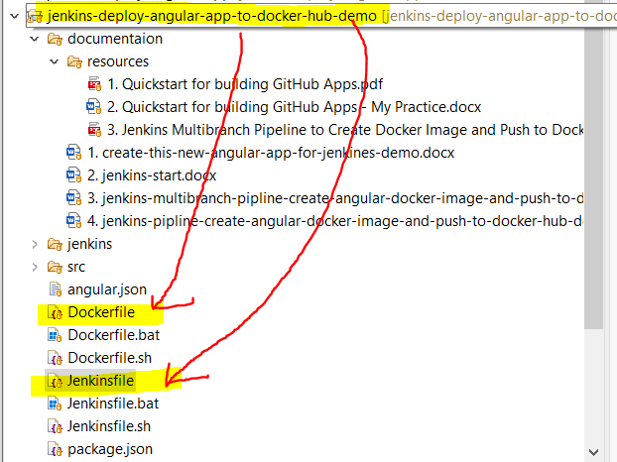

Dockerfile for creating angular docker image

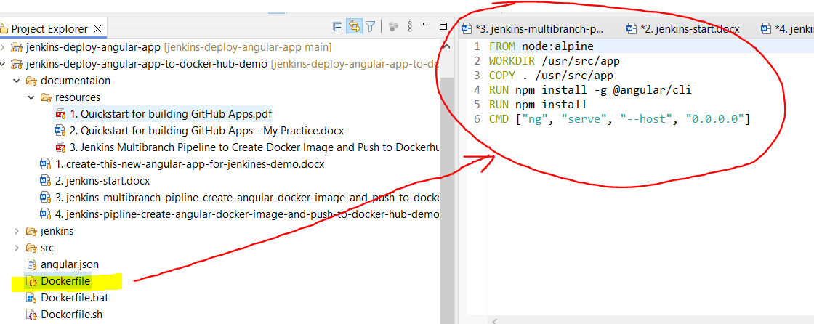

FROM node:alpine

WORKDIR /usr/src/app

COPY . /usr/src/app

RUN npm install -g @angular/cli

RUN npm install

CMD ["ng", "serve", "--host", "0.0.0.0"]

Jenkinsfile for deploy angular app to Docker Hub

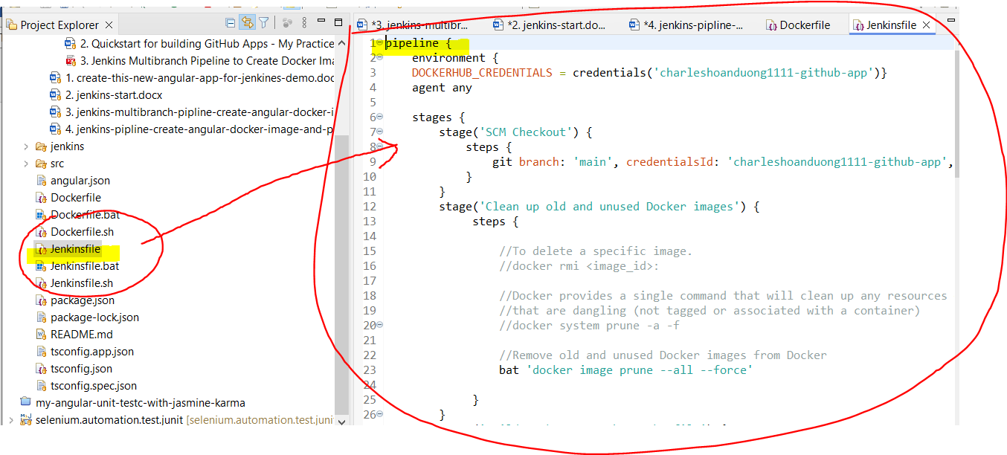

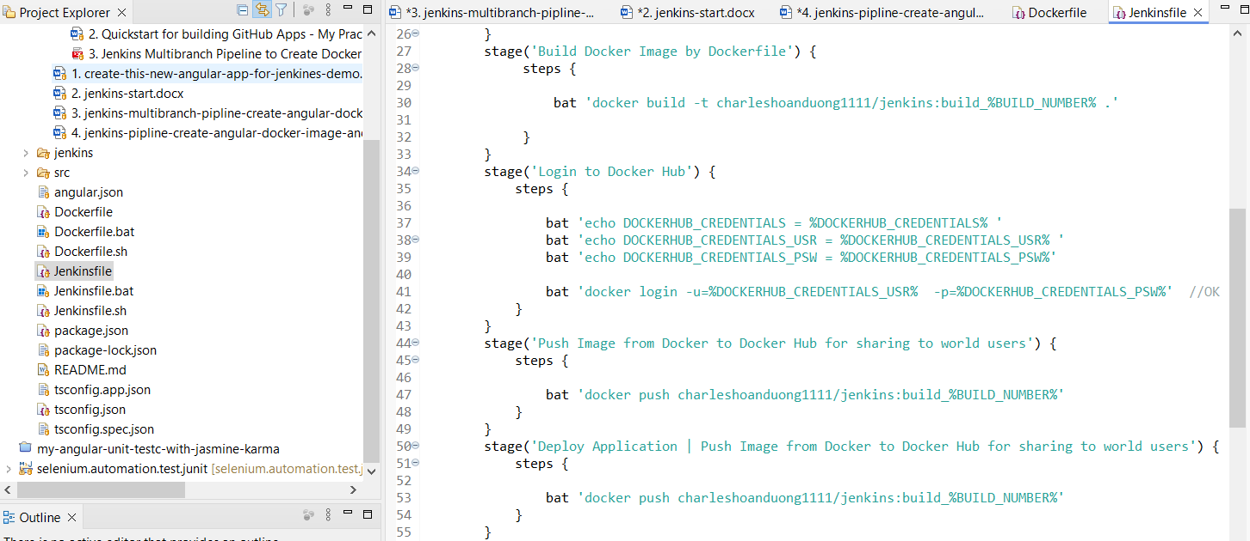

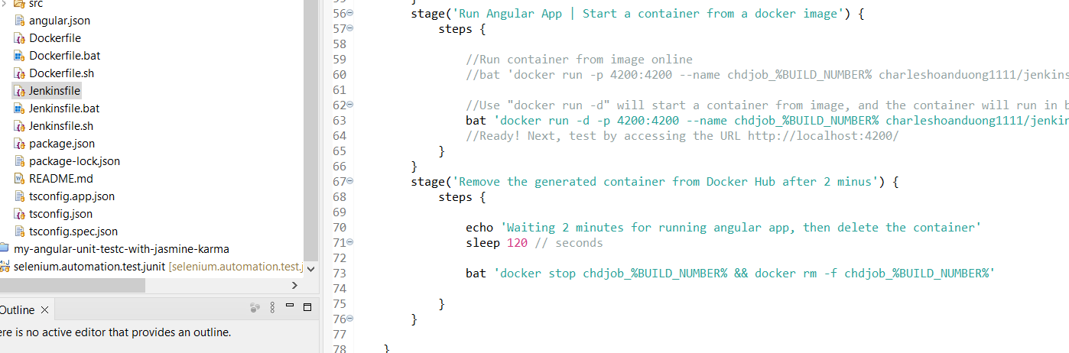

Jenkinsfile for deploy angular app to Docker Hub

pipeline {

environment {

DOCKERHUB_CREDENTIALS = credentials('charleshoanduong1111-github-app')

}

agent any

stages {

stage('SCM Checkout') {

steps { git branch: 'main', credentialsId: 'charleshoanduong1111-github-app', url: 'https://github.com/JenkinsCiCdDemo/jenkins-deploy-angular-app.git'

}

}

stage('Clean up old and unused Docker images') {

steps {

//Remove old and unused Docker images from Docker

bat 'docker image prune --all --force'

}

}

stage('Build Docker Image by Dockerfile') {

steps {

bat 'docker build -t charleshoanduong1111/jenkins:build_%BUILD_NUMBER% .'

}

}

stage('Login to Docker Hub') {

steps {

bat 'echo DOCKERHUB_CREDENTIALS = %DOCKERHUB_CREDENTIALS% '

bat 'echo DOCKERHUB_CREDENTIALS_USR = %DOCKERHUB_CREDENTIALS_USR% '

bat 'echo DOCKERHUB_CREDENTIALS_PSW = %DOCKERHUB_CREDENTIALS_PSW%'

bat 'docker login -u=%DOCKERHUB_CREDENTIALS_USR% -p=%DOCKERHUB_CREDENTIALS_PSW%'

}

}

stage('Push Image from Docker to Docker Hub for sharing to world users') {

steps {

bat 'docker push charleshoanduong1111/jenkins:build_%BUILD_NUMBER%'

}

}

stage('Deploy Application | Push Image from Docker to Docker Hub for sharing to world users') {

steps {

bat 'docker push charleshoanduong1111/jenkins:build_%BUILD_NUMBER%'

}

}

stage('Run Angular App | Start a container from a docker image') {

steps {

bat 'docker run -d -p 4200:4200 --name chdjob_%BUILD_NUMBER% charleshoanduong1111/jenkins:build_%BUILD_NUMBER%'

//Ready! Next, test by accessing the URL http://localhost:4200/

}

}

stage('Remove the generated container from Docker Hub after 2 minus') {

steps {

echo 'Waiting 2 minutes for running angular app, then delete the container'

sleep 120 // seconds

bat 'docker stop chdjob_%BUILD_NUMBER% && docker rm -f chdjob_%BUILD_NUMBER%'

}

}

}

}

Jenkins

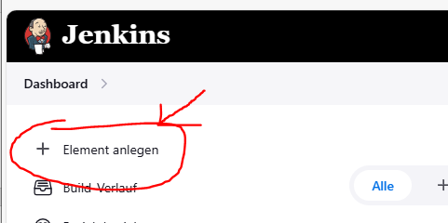

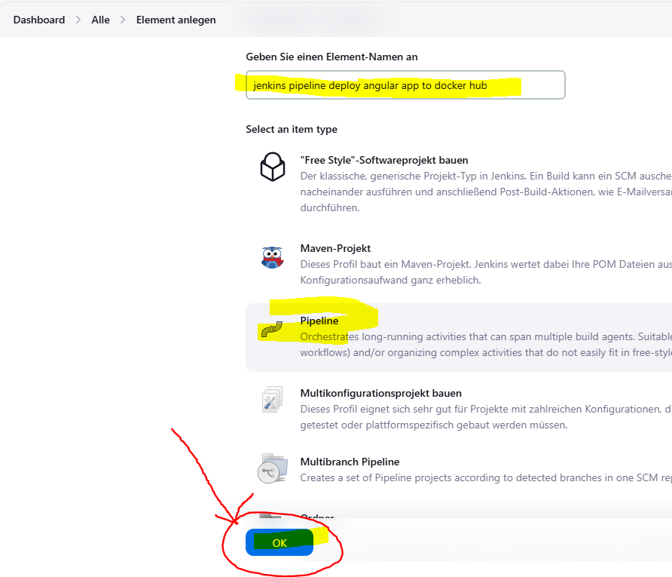

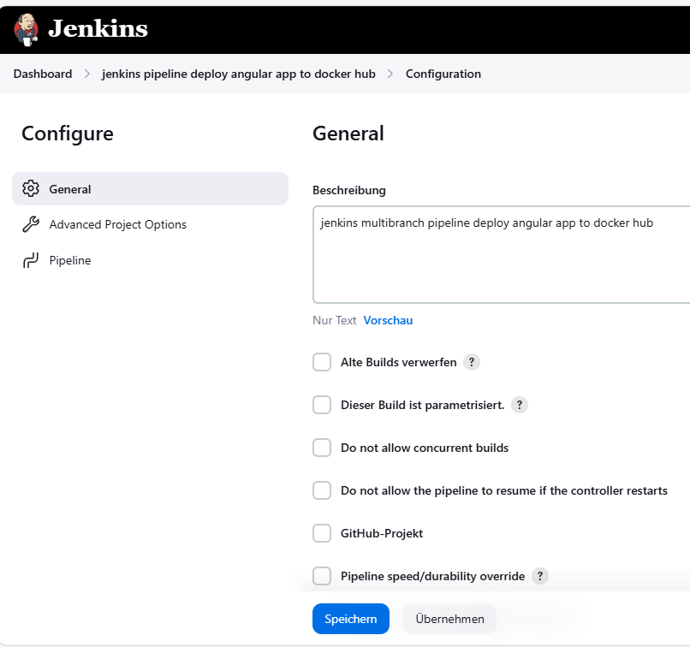

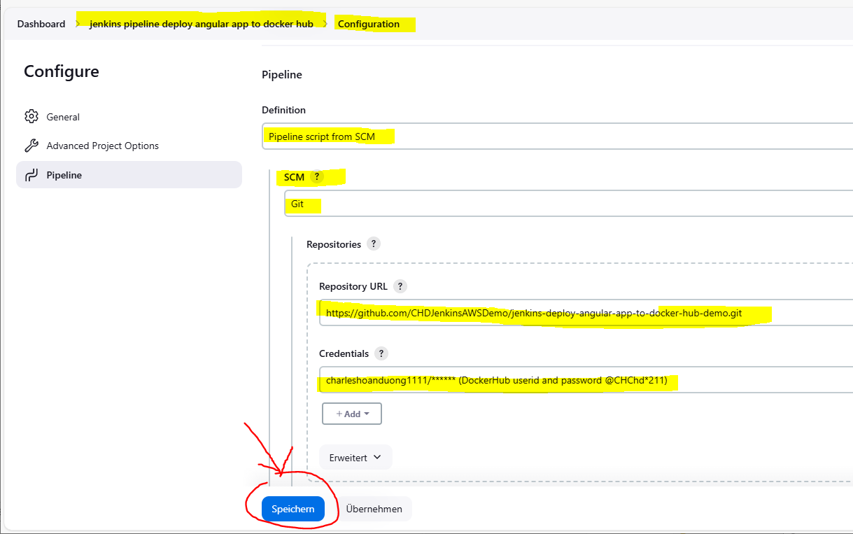

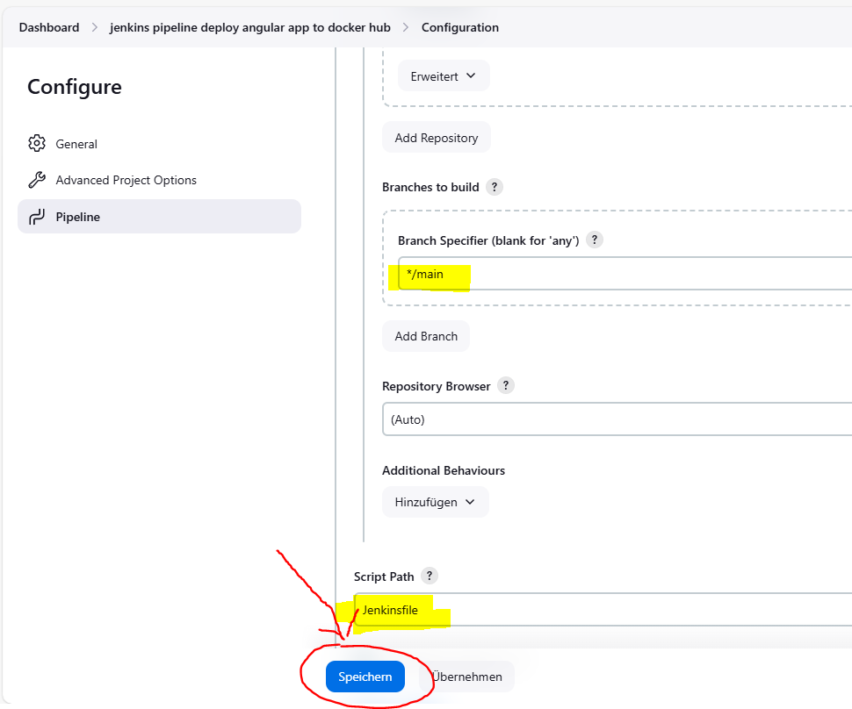

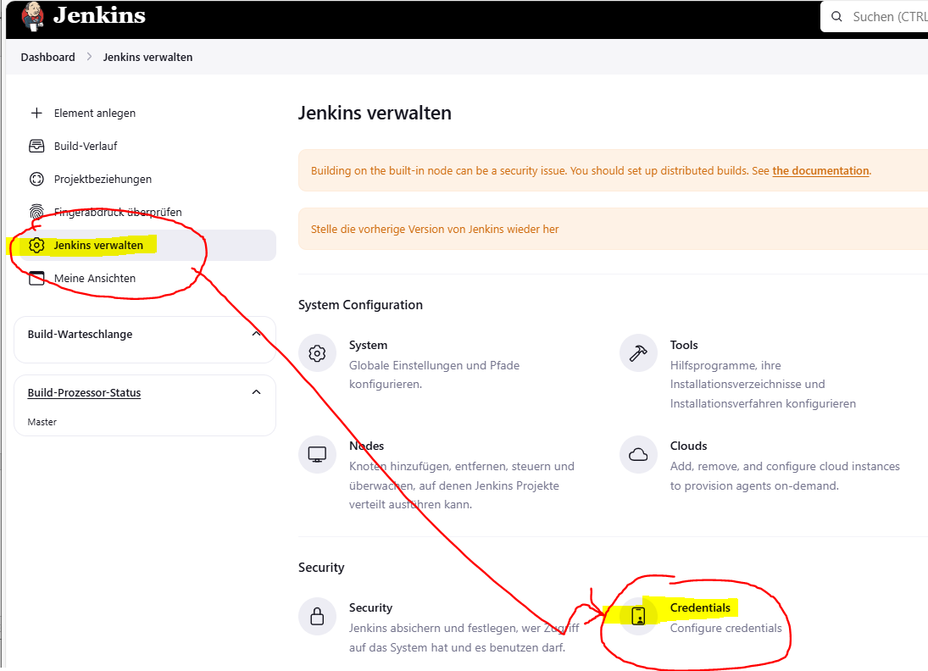

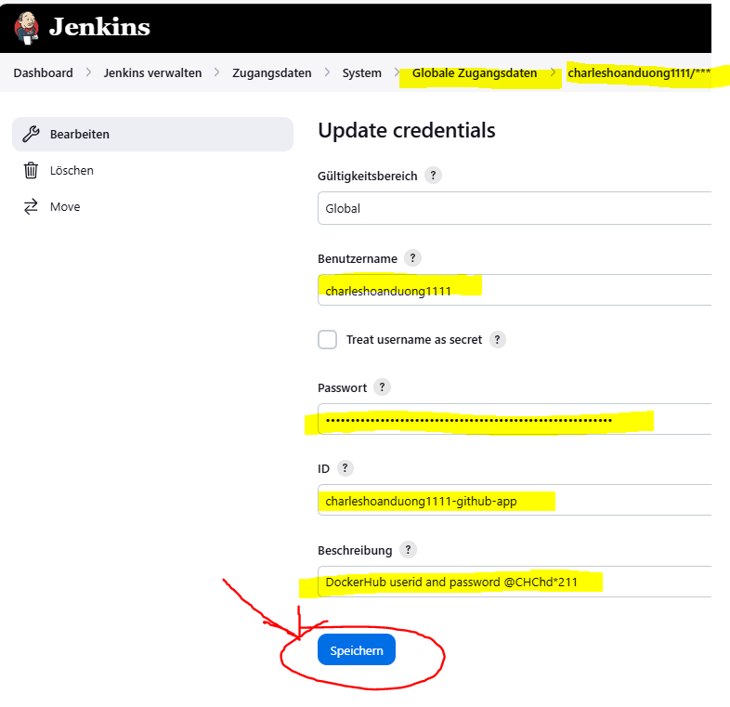

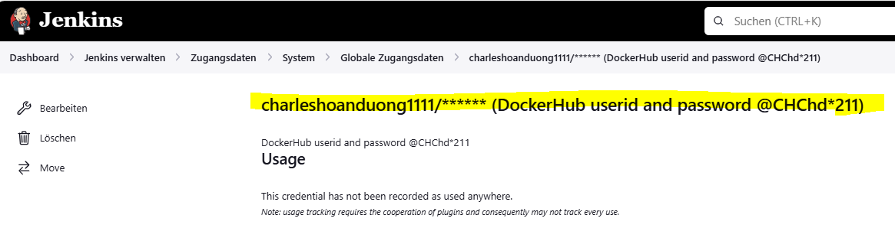

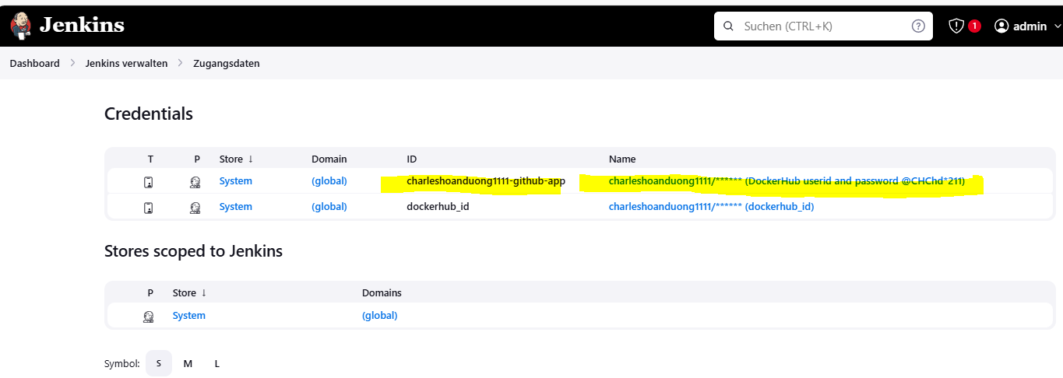

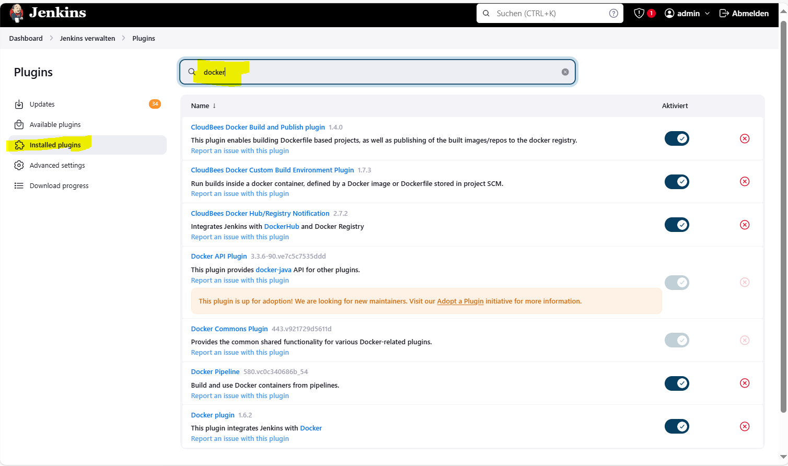

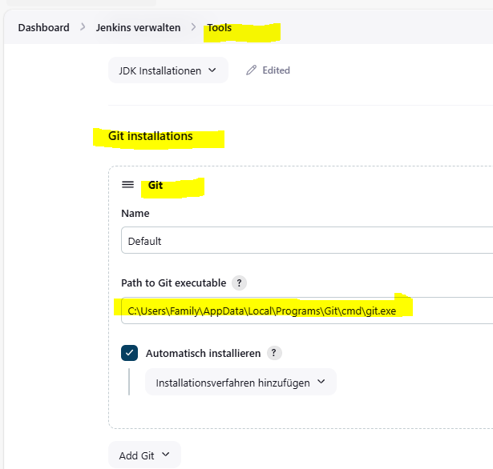

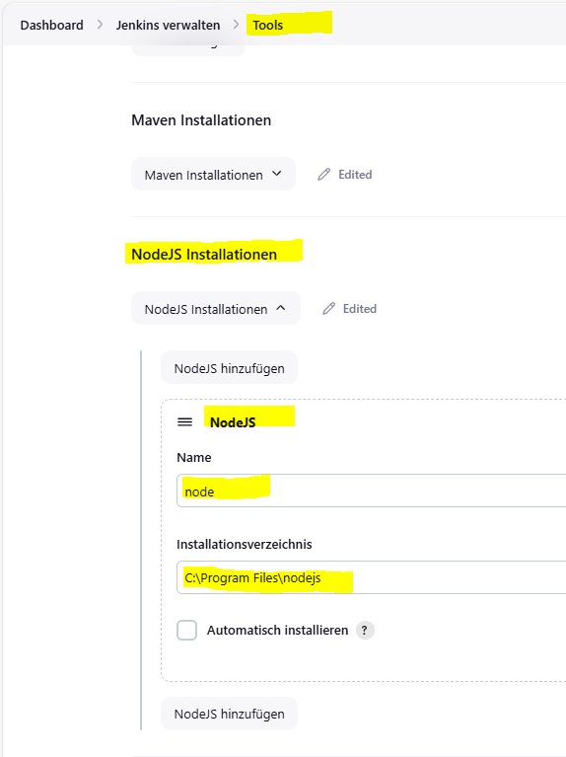

Jenkins 🡪 Build now

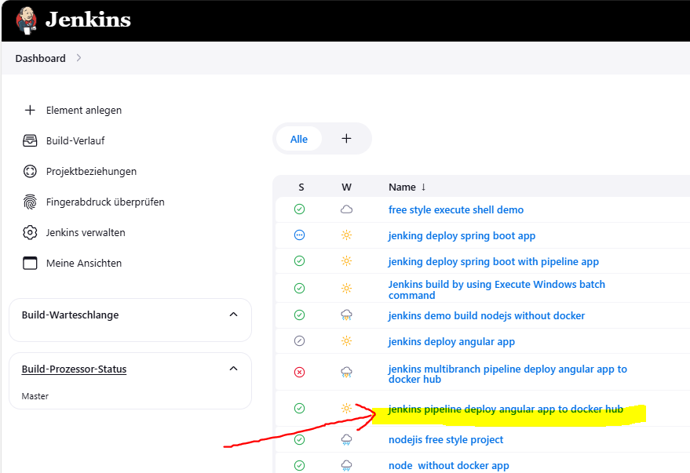

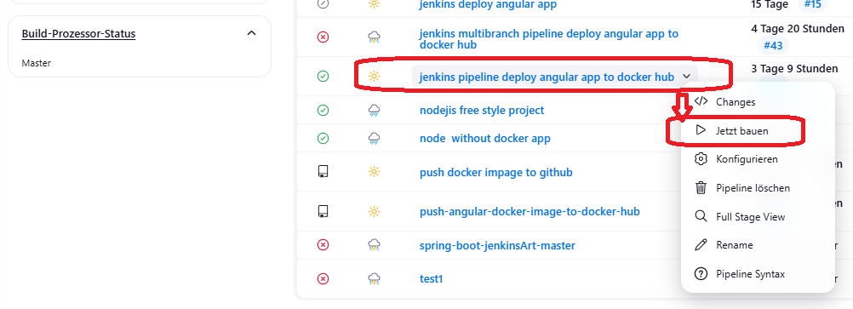

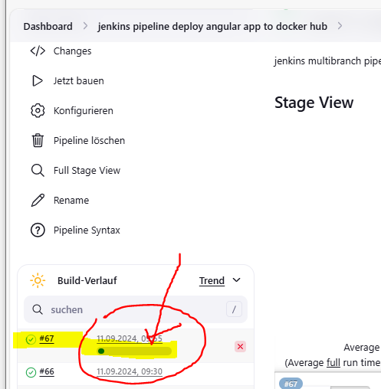

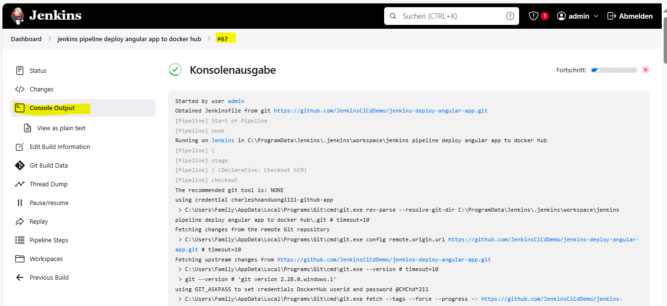

Using Dockerfile to generate angular docker image 🡪 OK

FROM node:alpine

WORKDIR /usr/src/app

COPY . /usr/src/app

RUN npm install -g @angular/cli

RUN npm install

CMD ["ng", "serve", "--host", "0.0.0.0"]

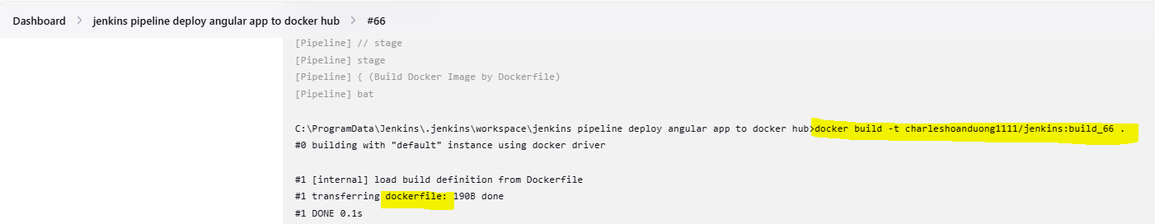

C:\Users\Family\git\jenkins-deploy-angular-app-to-docker-hub-demo>docker images

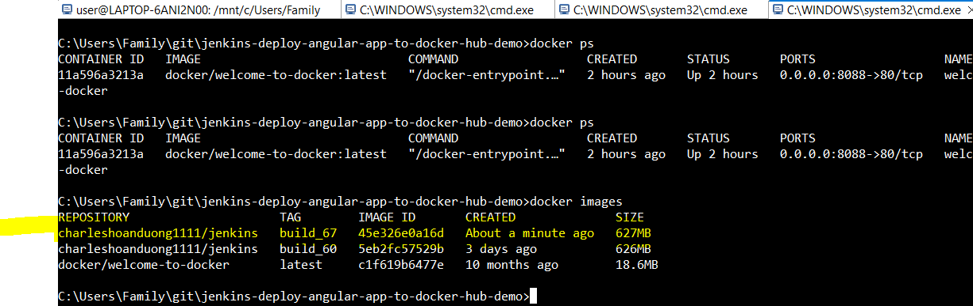

Using jenkinsfile to login Docker Hub 🡪 OK

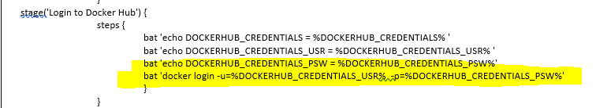

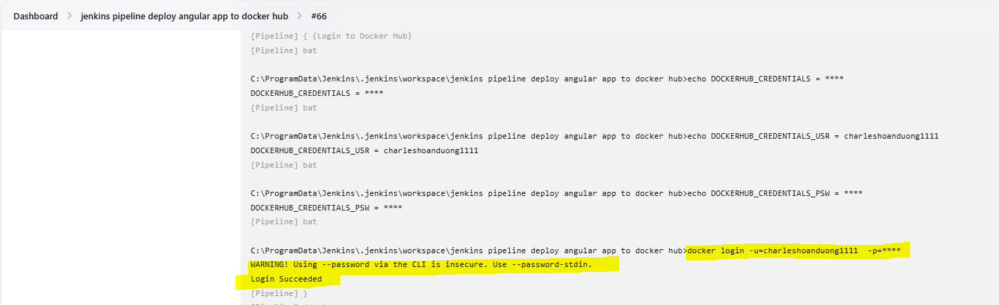

Using jenkinsfile to push to Docker Hub 🡪 OK

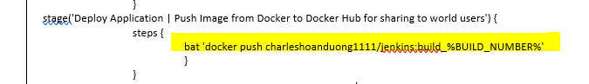

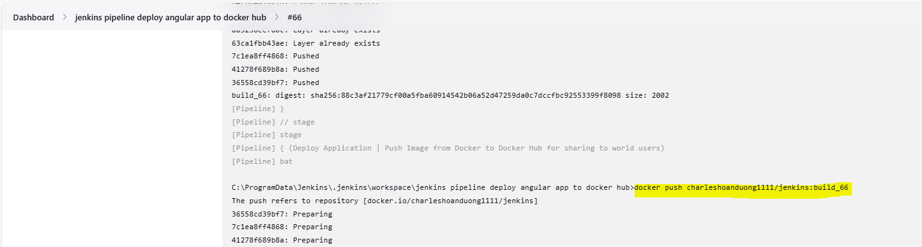

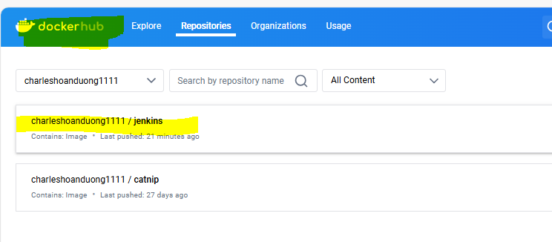

Using jenkinsfile to run to Angular App by starting a container from Docker image in background 🡪 OK

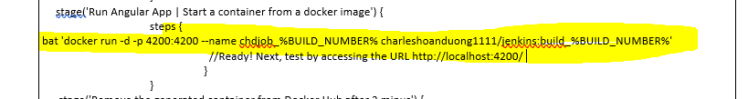

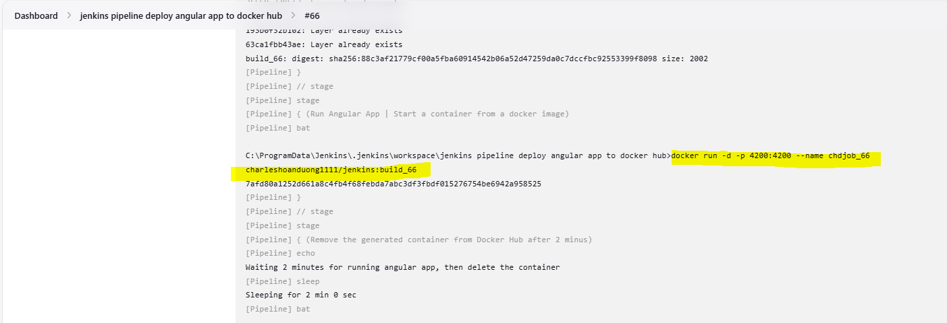

C:\Users\Family\git\jenkins-deploy-angular-app-to-docker-hub-demo>docker ps

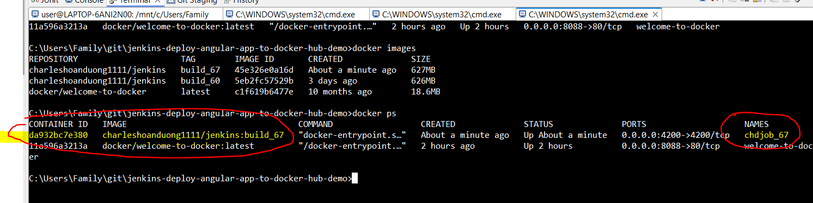

<http://localhost:4200/>  
  
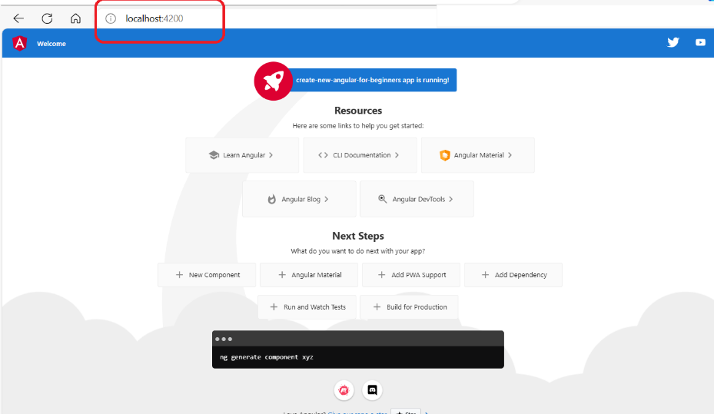

Using jenkinsfile to stop Angular App by delete the the container after waiting 2 minus 🡪 OK

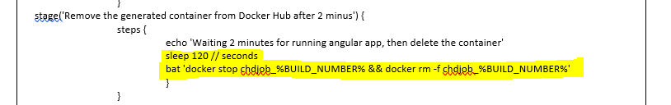

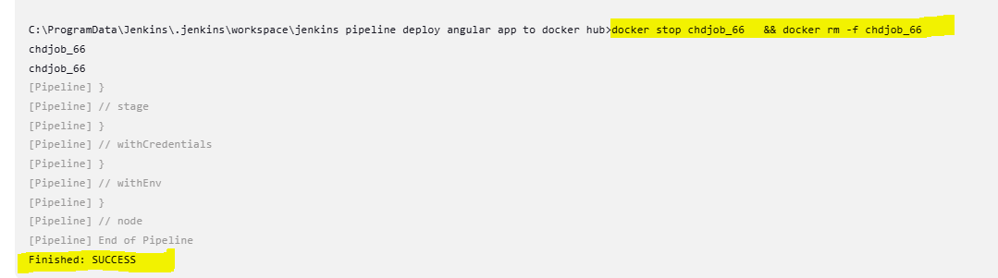

<http://localhost:4200/>

